UNIT TESTS

1. 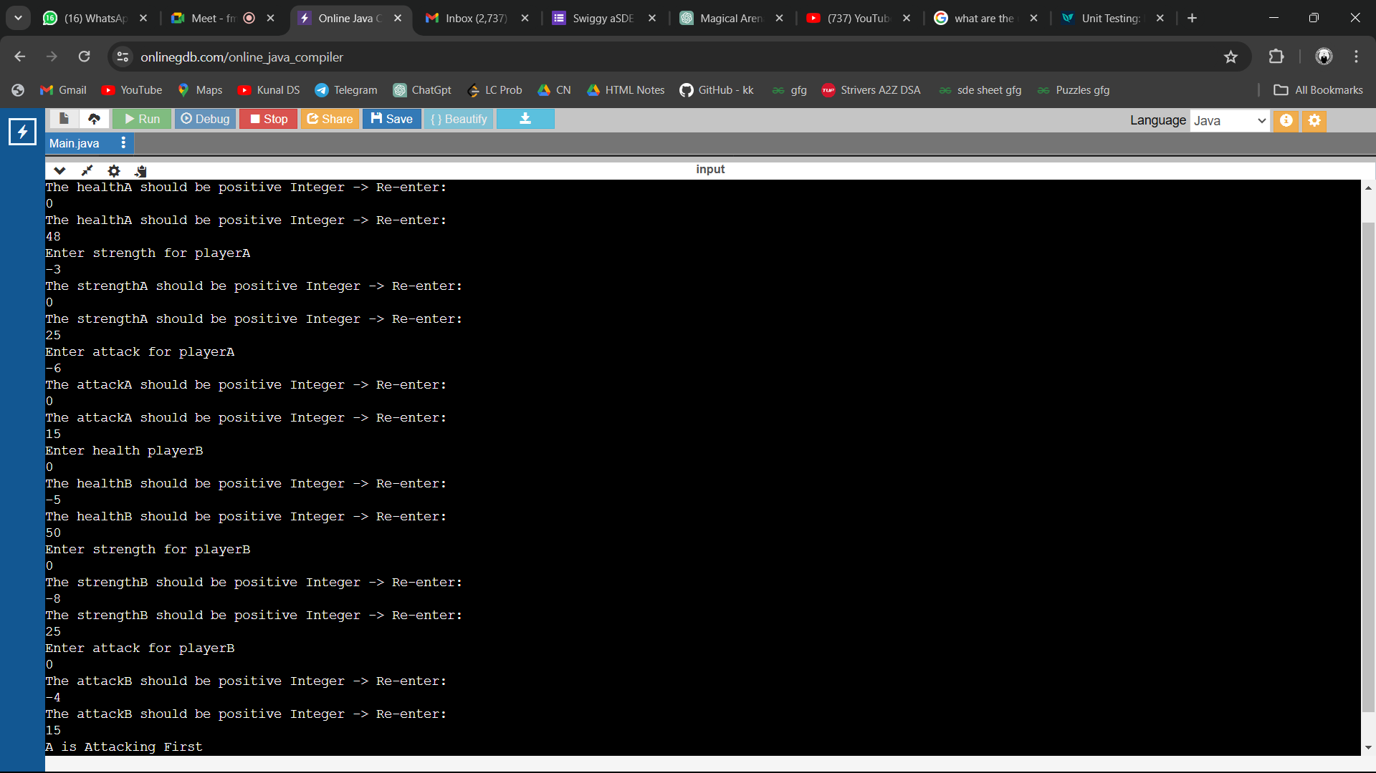

This is one of the case where all the attributes (health,strength,attack) of both the players A and B should be Positive Integers , if the values of any attribute is <= 0 then user will be prompted to re-enter that respective attribute value.

1. 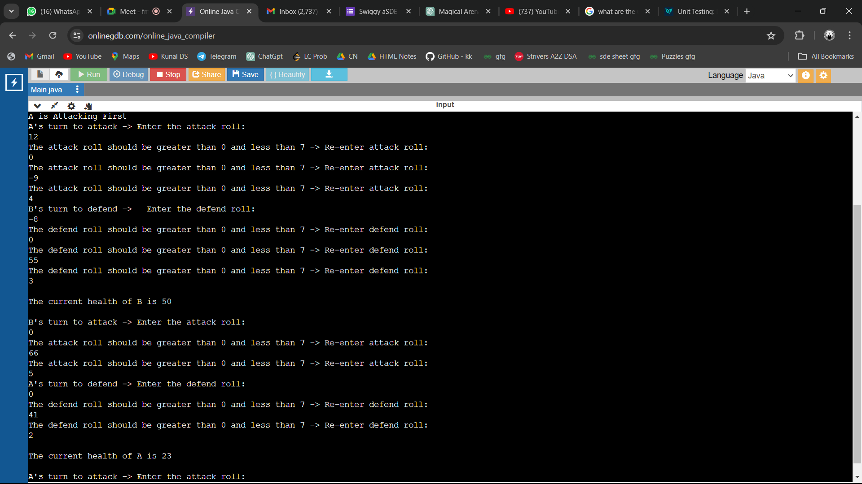

This is one of the case which shows that dice roll should be strictly >0 and <7 , if in case the entered value is <=0 or >= 7 then the user will be prompted to re-enter the dice value. This case also shows up the current value of the defender.

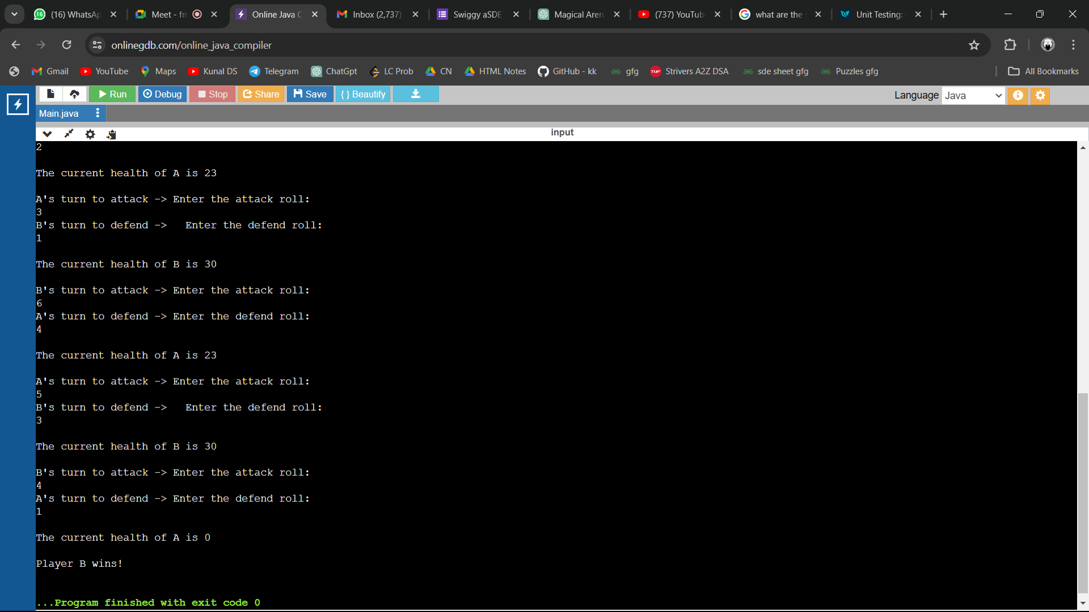

This is one of the case where one player’s health attribute value is 0 which implies that the opposite player wins the game. So here in the above scenario the player A’s health is 0 which declared player B as winner.

4)

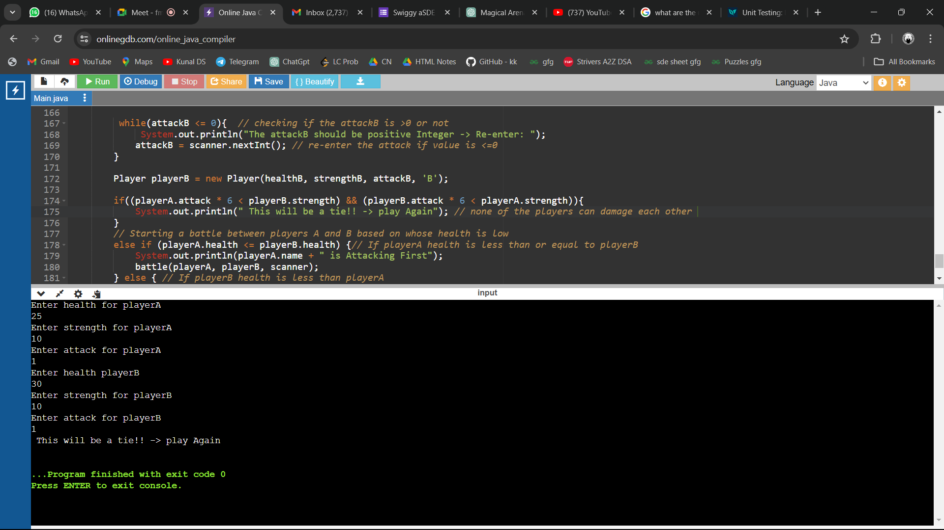

This is the case where one players maximum attack is less than the opponent’s minimum defence , this scenario will results in a tie and the user need to play the game again